**LAPORAN PRAKTIKUM 11**

**PERCOBAAN 1**

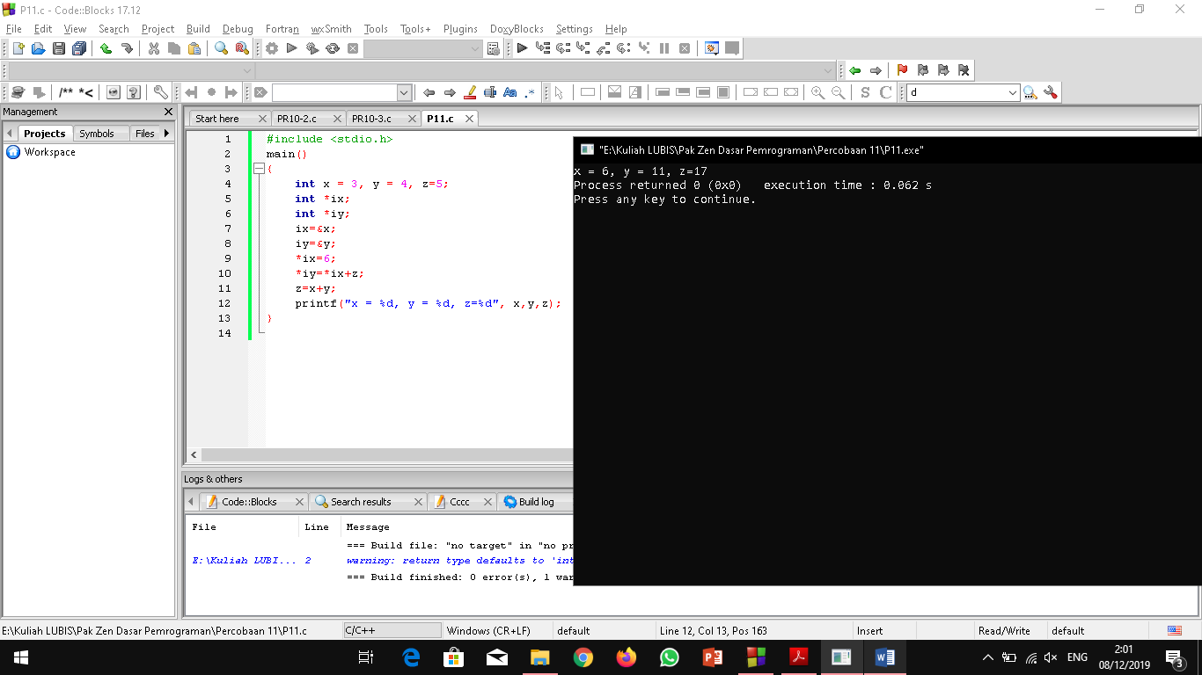

#include <stdio.h>

main()

{

int x = 3, y = 4, z=5;

int *ix;

int *iy;

ix=&x;

iy=&y;

*ix=6;

*iy=*ix+z;

z=x+y;

printf("x = %d, y = %d, z=%d", x,y,z);

}

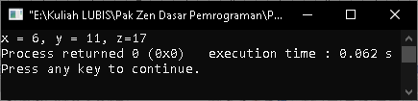

**PERCOBAAN 2**

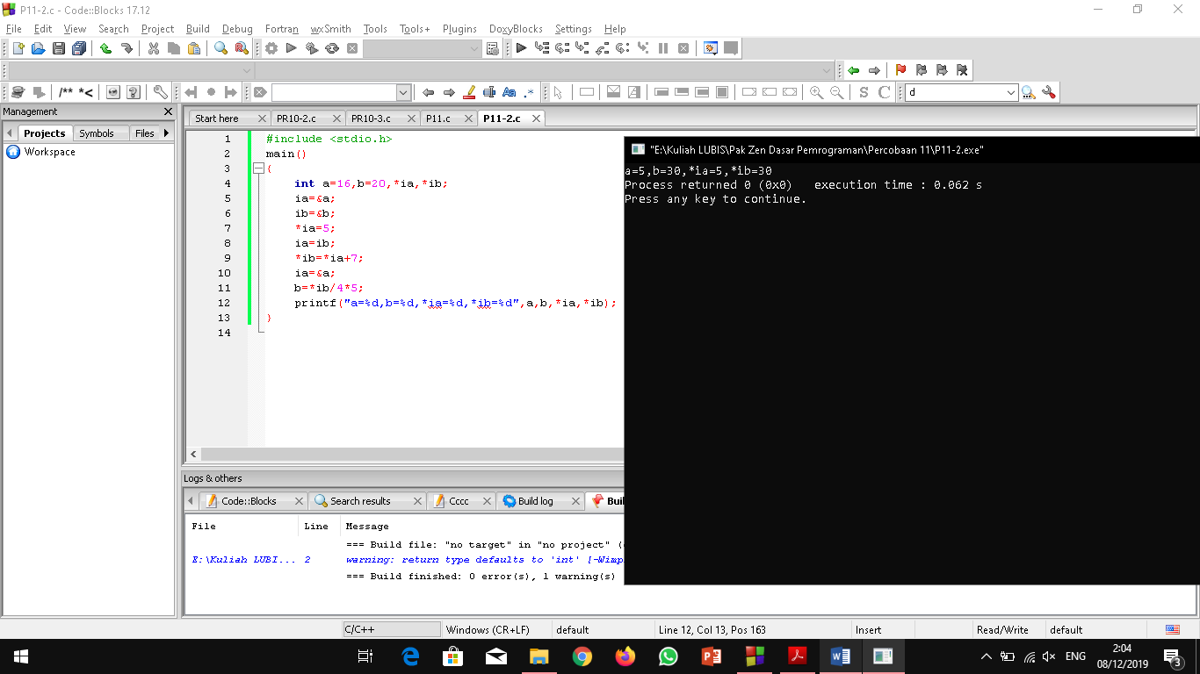

#include <stdio.h>

main()

{

int a=16,b=20,*ia,*ib;

ia=&a;

ib=&b;

*ia=5;

ia=ib;

*ib=*ia+7;

ia=&a;

b=*ib/4*5;

printf("a=%d,b=%d,*ia=%d,*ib=%d",a,b,*ia,*ib);

}

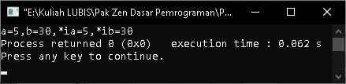

**PERCOBAAN 3**

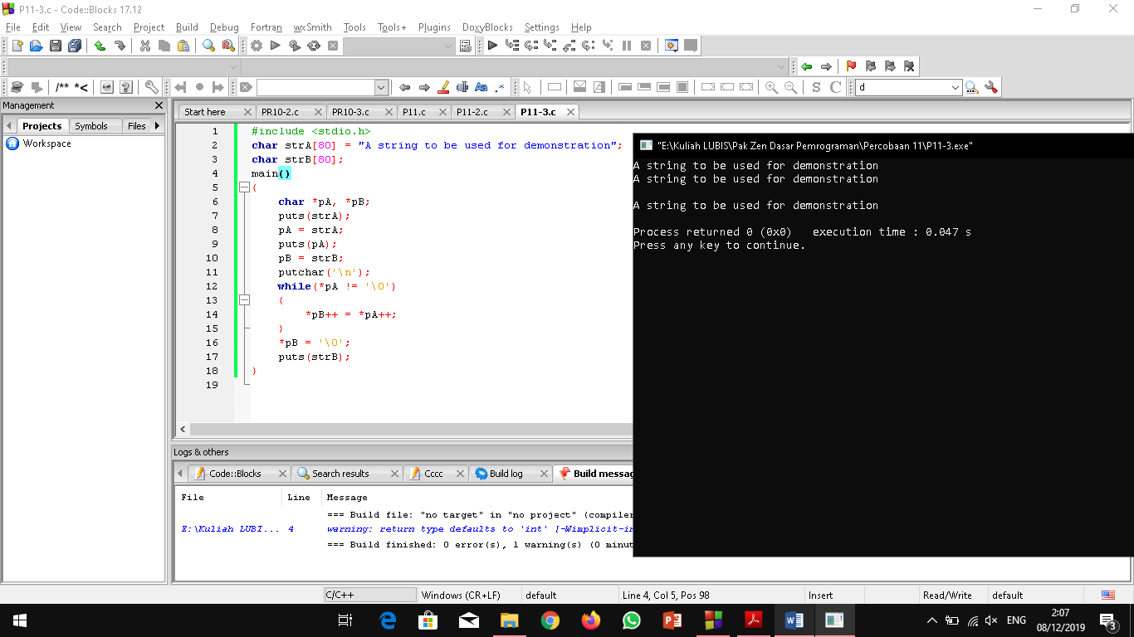

#include <stdio.h>

char strA[80] = "A string to be used for demonstration";

char strB[80];

main()

{

char *pA, *pB;

puts(strA);

pA = strA;

puts(pA);

pB = strB;

putchar('\n');

while(*pA != '\0')

{

*pB++ = *pA++;

}

*pB = '\0';

puts(strB);

}

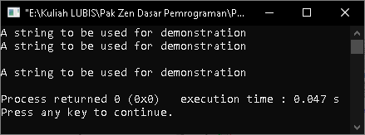

**PERCOBAAN 4**





|  |
| --- |
|  |
|  |
|  |
|  |
|  |
|  |
|  |
|  |
|  |
|  |
|  |
|  |
|  |
|  |
|  |

**PERCOBAAN 5**

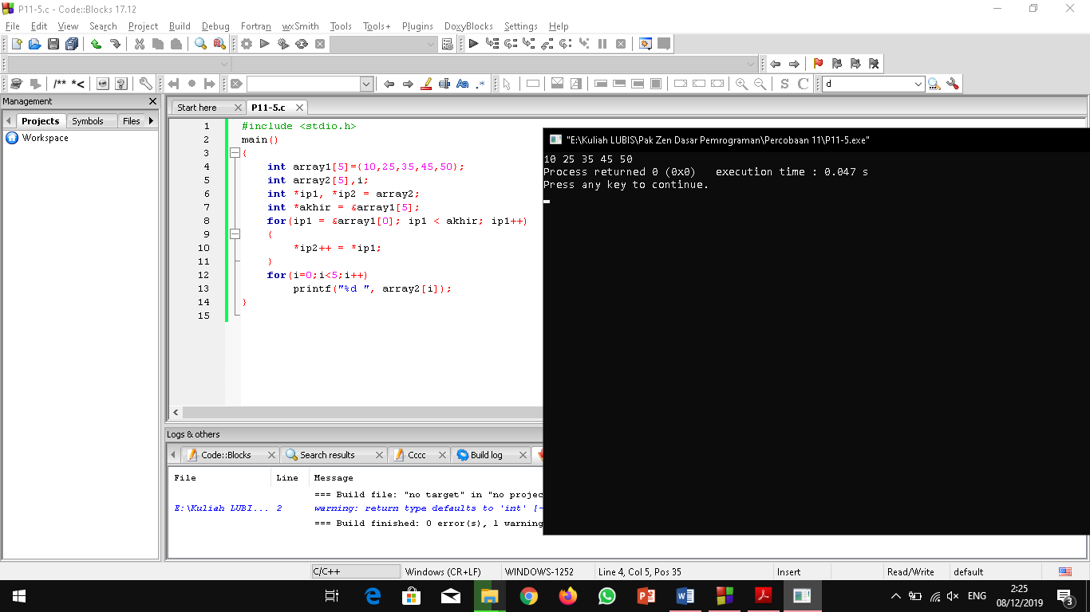

#include <stdio.h>

main()

{

int array1[5]={10,25,35,45,50};

int array2[5],i;

int *ip1, *ip2 = array2;

int *akhir = &array1[5];

for(ip1 = &array1[0]; ip1 < akhir; ip1++)

{

*ip2++ = *ip1;

}

for(i=0;i<5;i++)

printf("%d ", array2[i]);

}

